**PROGRAMMING PROJECT 3**

**README FILE**

Yes, Our java code is working as per the requirement. Firstly, we are giving input as an infix expression and converting it into postfix. Here, we are considering 8 bit decimal numbers (-127 to 128). Also we have taken operators and parentheses to specify the order of operations. We also included the overflow condition where we have applied 2’s complement for addition and subtraction. For multiplication and division 2’s complement is complex so we have applied magnitude.

**Steps for Compiling the program**

* To run the program, save the file in the folder. Open the folder in visual studio code.
* Once we run the java program, it will first ask for the infix expression.
* For the given infix expression we are converting it into postfix and then generating the result by calculating it.
* If the infix expression starts with ‘-’, then in the post fix expression it is converted to ‘^’.
* We have also checking overflow conditions,

For Addition and subtraction, we have used 2’s complement, and printed the result with a difference of 8 bit numbers.

For multiplication and division 2’s complement is complex so we have applied magnitude.

**Test Cases:**

1. **Infix: 40+50**

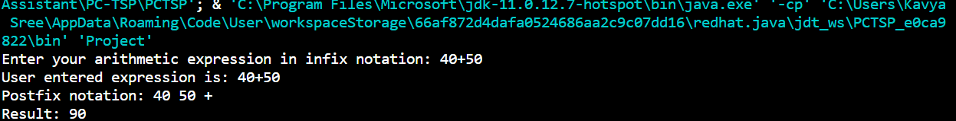

1. **Infix: 45+(-50)**

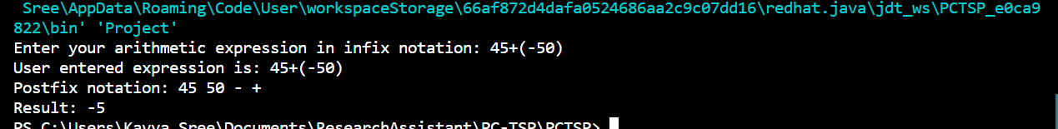

1. **Infix: 80+80 (Overflow)**

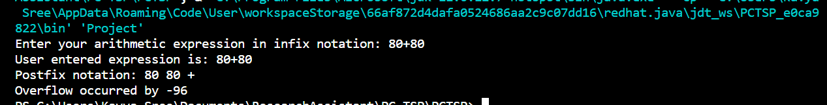

1. **Infix: -36+107**

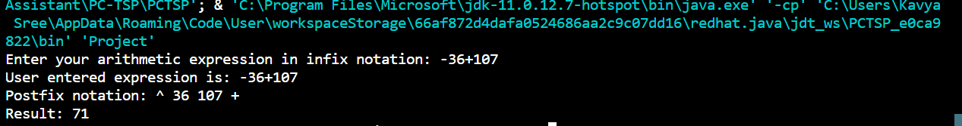

1. **Infix: -50-122 (overflow)**

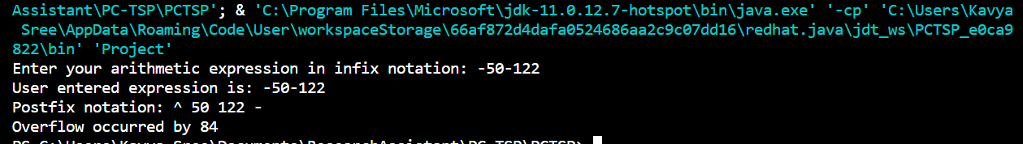

1. **Infix: -33*3**

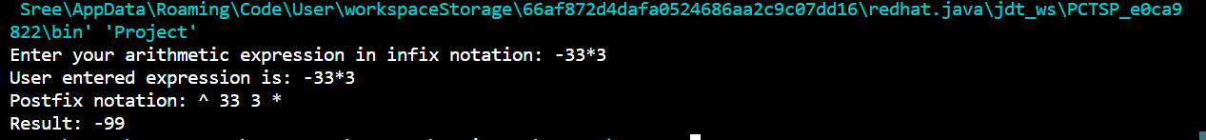

1. **Infix: 101*61 (overflow)**

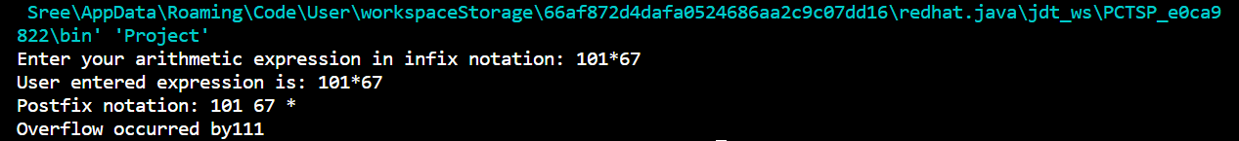

1. **Infix: -70/3**

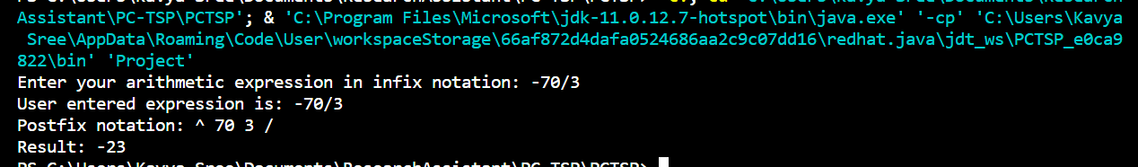

1. **Infix: -120/(-34)**

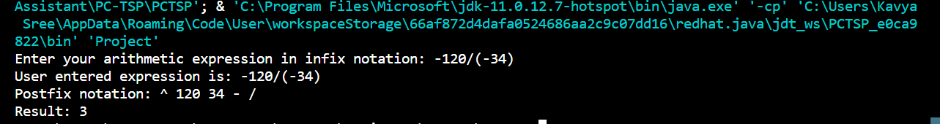

**Extra Test Cases:**

1. **Infix: 2 * (1 + 2) ^ 3**

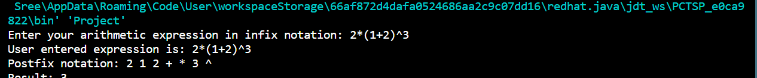

1. **Infix: 7 ^ 3 - 3 * 7 ^ 2 + 7**

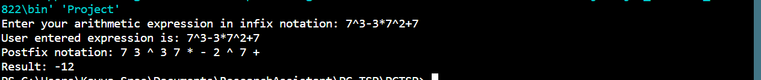

1. **Infix: (255 - 127) * 3**

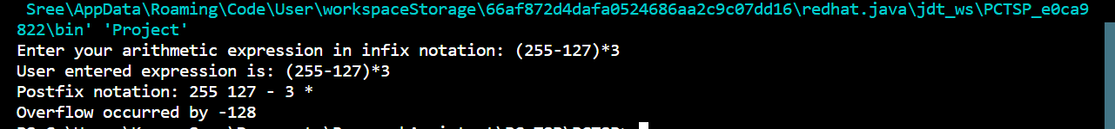

1. **Infix: -3+(4+5)*9**

